Colorado 4-H
Secretary Book

Club Name: |  | Year
County:

President | Vice President
Secretary | Treasurer
Reporter | Historian/Scrapbook

What is 4-H?
4-H is a community of young people, across America, learning leadership, citizenship, and life skills.

THE 4- PLEDGE
I pledge my Head to clearer thinking,
my Heart to greater loyalty,
my Hands to larger service,
my Health to better living,
for my club, my community, my country, and my world.

THE 4-H CLUB MOTTO

To Make the Best Better

THE 4-H CLUB EMBLEM
The 4-H emblem is a four-leaf clover with the letter "H" on each leaf.
The four "H's" stand for Head, Heart, Hands, and Health.

THE 4-H CLUB COLORS

GREEN: Nature's most common color is emblematic of springtime, life, and youth.

WHITE: Symbolizes purity and high ideals.

Congratulations! Serving as 4-H secretary is certainly an honor, but it also includes many duties and responsibilities. You should become familiar with these so you can serve your club well and keep a good record of all the club’s activities through the year.

Use this 4-H Secretary’s Book to keep accurate minutes of meetings records of attendance and participation of members. You will write correspondence and complete the monthly minutes.

Duties of the Secretary
• Arrive at the meeting ahead of time. Sit next to the president during the business meeting.

• Keep an accurate record of proceedings from business and officer meetings. (Record any officers elected, committees appointed and other business brought before the club.

• Keep club attendance and participation records.

• Read minutes of the last meeting. Make corrections give by club members and leaders.

• Discuss items of business with the other officers and the club leaders.

• Read any correspondence directed to the club. Write correspondence for the club as
needed.

• Collect written reports from committees and include reports in minutes of the meeting. Record all motions and whether they pass or fail.

• Call meeting to order in absence of president and vice-president and have a temporary chair elected to preside.

• Maintain the Calendar of 4-H Club Activities included in this book.

• Assist the president during the meeting by restating the motion as it is presented and recorded in the minutes.

• Maintain a record of all officers, standing committees and special committees.

• Inform the president if it is necessary for you to be absent. The president will appoint a temporary secretary for the meeting.

Writing Minutes

One specific responsibility of the 4-H secretary is to keep accurate minutes of each meeting. Keep good notes during the meeting by using the worksheet included in this book. You should write the minutes within one week of the meeting, while the meeting information is still fresh in your mind.

These items should be included in the minutes:

- Name of club or group.
- Kind of meeting-regular or special.
- Date, hour and place of meeting.
- The presiding officer
- Approval of previous minutes and report of the treasurer and other officers.
- Motions made and action taken,
- Names of members appearing on program and description of the program.
- Description of educational program given by leader, members or others.
- Signature of secretary.

Secretary Guidelines

Before the Meeting...
Gather and arrange in convenient order all correspondence received.
Check with the leader to make sure the roll call list is up to date.
Check the minutes of the last meeting and make a note for the president of old business items that need to be discussed.
If you can’t attend the meeting, tell the president and leader in advance.+

After the Meeting...
Write the minutes as soon as possible.
Sign the minutes
Write any correspondence or thank you letters if needed.

After the last club meeting for the year...
Write the minutes and organize all your secretary materials for the new club secretary.

Roll Call of members
Name of Member | Oct | Nov | Dec | Jan | Feb | Mar | Apr | May | June | July | Aug | Sept

Roll Call of member Event Participation
Name | Club Ofic | Comm Service | Club Comm | Fund Raising | Dist ofc | State Ofc | State Conf | CWF | Nation  Conf | Nat Congres | County Fair | State Fair

Sample
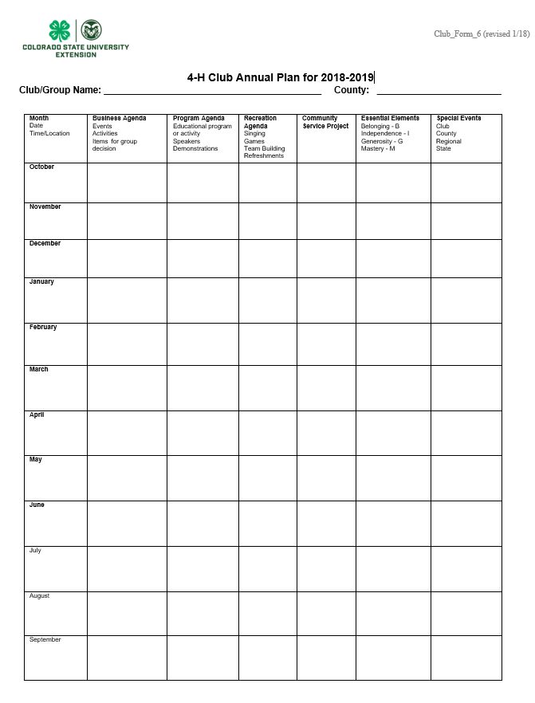

This page can be found on the website at: http://co4h.colostate.edu/volunteer-resources/club-group-resources/

 | 4-H Meeting Notes Worksheet
√ | 4-H Meeting for: |  |  |  |  |  |  | Date:
√ | Location: |  |  |  |  |  |  | Time:
√ | Opening
 | Pledge of Allegiance by:
 | 4-H Pledge by:
 | Roll Call question was:
 | Members |  | Leaders |  | Parents |  | Guests
√ | Officer Reports:
 | Minutes of last meeting approved as: Read Corrected
 | Correspondence:
 | Treasurer Report:
 | Reporter:
 | Historian/Scrapbook
 | Leaders:
√ | Committee Reports:
√ | Member Reports
√ | Old Business
√ | New Business
√ | Announcements
√ | Adjourned:
√ | Program/Demonstrations:
√ | Refreshments provided by:
√ | Recreation led by:

Calendar of 4-H Club Activities
4-H Year – October 1 – September 30

List here the special activities that are to be conducted during the year. In the “club” column would your club activities, such as a project tour, a picnic and a Christmas party,
In the “county” column would be county activities like the Achievement Night, 4-H Carnival and County Fair.
Under “state” would be activities like District meetings, State 4-H Conference, LDC and State Fair. The dates of county and state activities may be obtained from your organizational leader or your county newsletter. Check your county webpage for all county events and the state webpage for upcoming events.

The day of the month an activity is to be held may be shown as follow: 30-Project Tour- .
This would mean the project tour was to be on the 30th of the month in which it was listed.

Example of how to list club activities
Month | Club | County | State
December | 20- Christmas Party
March |  | 25- Carnival
June | 30- Project Tour |  | 18-23 State Conference

Club Calendar for October 20 - September 20

Month | Club | County | State

October
November
December
January
Month | Club | County | State
February

March
April
May
June
July
August
September

 | Meeting Notes Worksheet
√ | 4-H Meeting for: Blue Ribbon Club |  |  |  |  |  |  | Date: 4/14/2018
√ | Location: Big Springs Grange |  |  |  |  |  |  | Time: 7pm
√ | Opening
 | Pledge of Allegiance by: Joy White
 | 4-H Pledge by: Brandon Sargent
 | Roll Call was: What was the last movie you went to?
 | Members | 23 | Leaders | 5 | Parents | 8 | Guests
√ | Officer Reports:
 | Minutes of last meeting approved as: √ Read Corrected
 | Correspondence: A thank you card from The Shelter was read, thanking the club for their work on the food drive.
 | Treasurer Report: A bill for 23.50 for carnival to Jean Rose, Alex moved, Amanda seconded to pay, interest income of 55 cents, balance is 102.54
 | Reporter: Wrote a story for the Triangle News, published in March issue.
 | Historian/Scrapbook New pictures were added from the Christmas Party
 | Leaders Do you need help with projects or record books?
√ | Committee Reports: need volunteers for Snack bar at fair
√ | Member Reports: Jane talked about the Cake Decorating Workshop and Joe went to the Leathercraft Workshop
√ | Old Business: Report from Carnival, made 212.00
√ | New Business: work at river park clean on 6/1, moved by Anne, second by Ken.
√ | Announcements: County Dog Show on May 21st.
√ | Adjourned: 7:45 moved by Jenny, seconded by Anne
√ | Program/Demonstrations: Ginger – How to load a .22 safely, James- Basic Cake Decorating Tools
√ | Refreshments provide by: Jones Family
√ | Recreation led by: Jim and Amanda

Sample Minutes

The regular monthly meeting of the Blue Ribbon 4-H Club was held on April 14, 2005 at the Big Springs Grange Hall. President Katy Woods called the meting order at 7:00 pm. Joy White led the Pledge of Allegiance and Brandon Sargent led the 4-H pledge. Roll call was answered with “ What was the last movie you attended?. There were 23 members, 8 parents and no guests in attendance. The minutes of the last meeting were approved as read. A card from The Shelter was read thanking the club for their work on the food drive.
The treasurer reported a bill from Jean Rose for $23.50 for carnival supplies. Alex Miles moved to pay the bill and Amanda Sharp seconded the motion, and the club voted to pay the bill. There was interest income of 55 cents for a total in the bank of $102.54.
Kristen Yates, Scrapbook, reported that the Christmas Party Pictures were in the scrapbook if anyone wanted to look at them after the meeting. Ken Yates, reporter wrote a story for the Triangle News that was in the March issue of the paper.
Mrs. Woods reminded everyone that county fair is coming up and asked if anyone needed help with projects and record books. The County Dog Show is on May 14th at the fairgrounds.
The Community Service Committee needs members to volunteer for working at the County Snack Bar during fair. Our club is responsible for one six hour shift during fair.
Jane and Lindsey went to the county Cake Decorating workshop and Joe attended the Leathercraft Workshop.
Old Business – The club booth at Carnival was busy and the club made $212.00 for future club activities. Under new business, Anne moved the club volunteer to work on Saturday June 1st at the River Park Clean-up Day , Ken seconded the motion and it was passed. Joan moved to Adjourn. The motion was seconded and passed.

Demonstrations: How to Load a .22 Rifle Safely – Ginger Smith, The Basic Tools of Cake Decorating – James Smith.

Refreshments were provided by the Jones Family and Recreation was led by Jim and Amanda.

Approved: Date___________ Respectfully submitted:____________________________

President:___________________________________

Include your club Bylaws and Constitution here.

